Homework 1

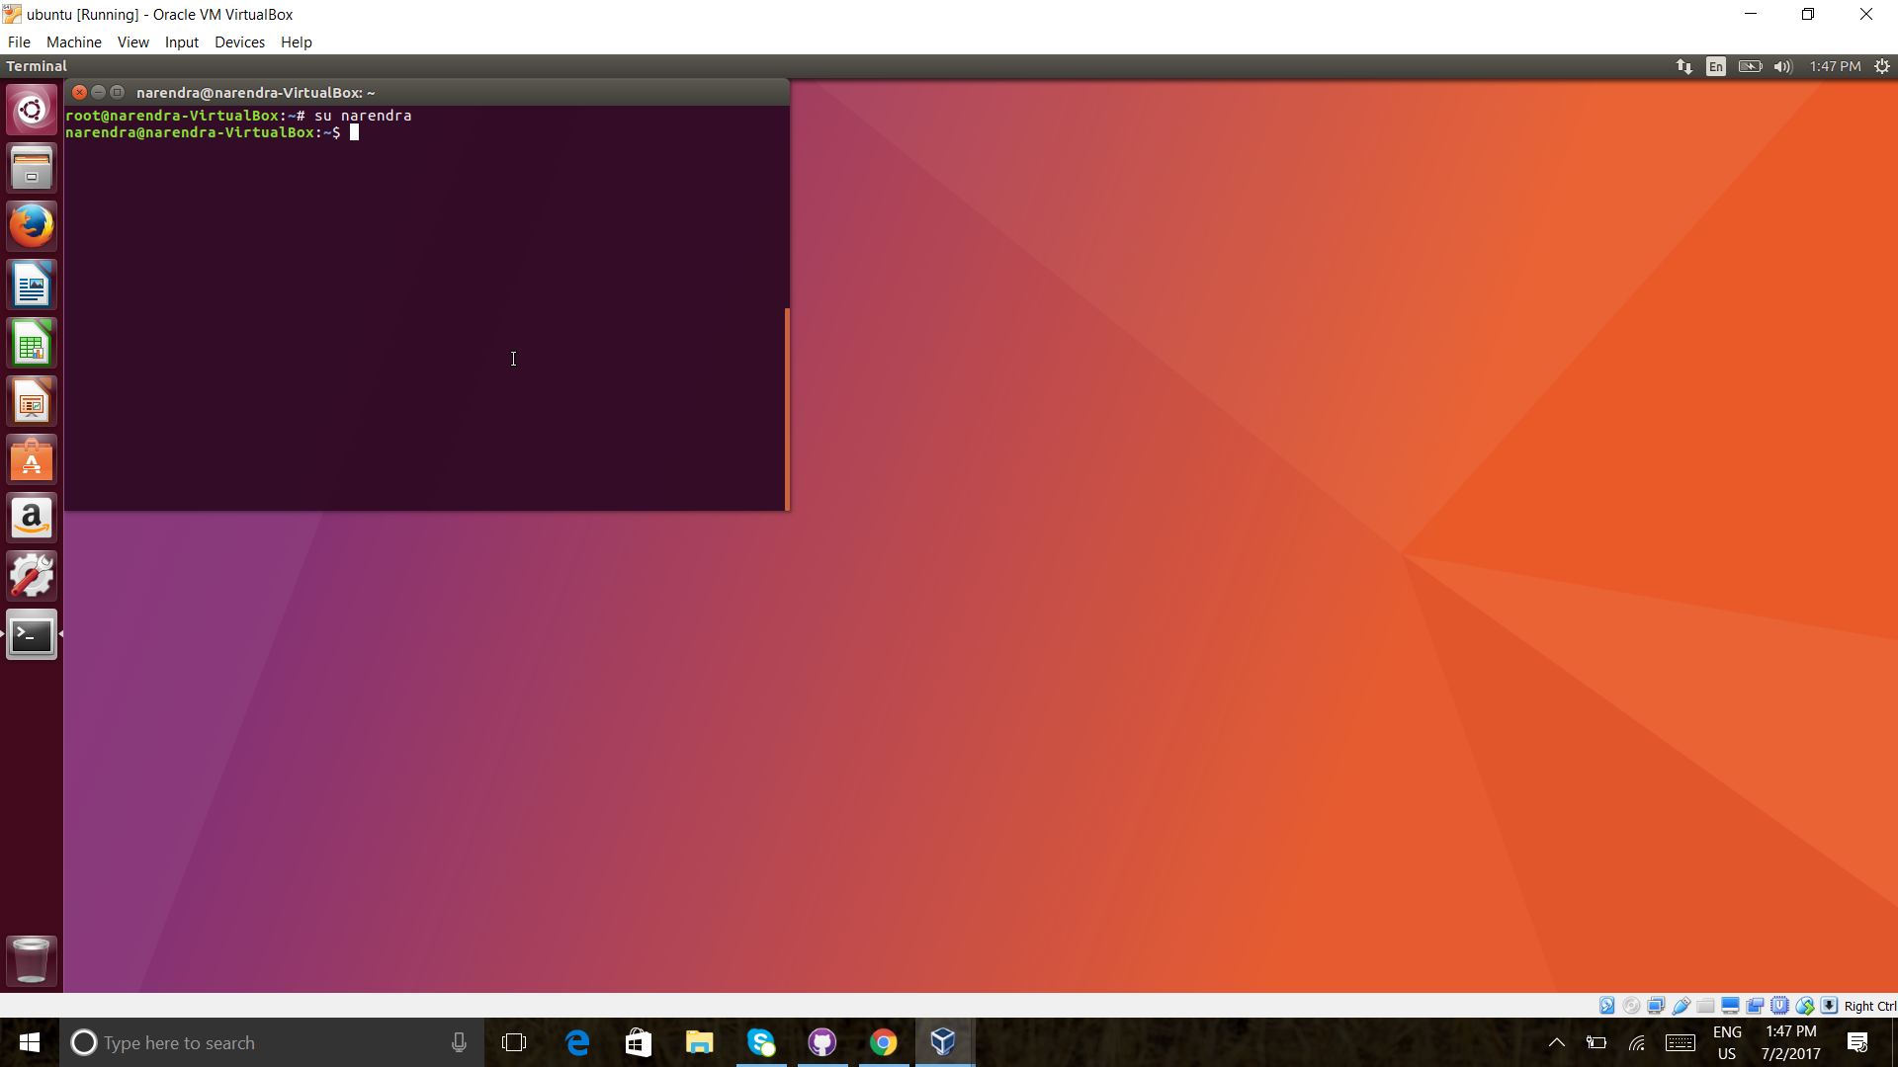
user ROOOT to normal user

sudo bash

cd narendra

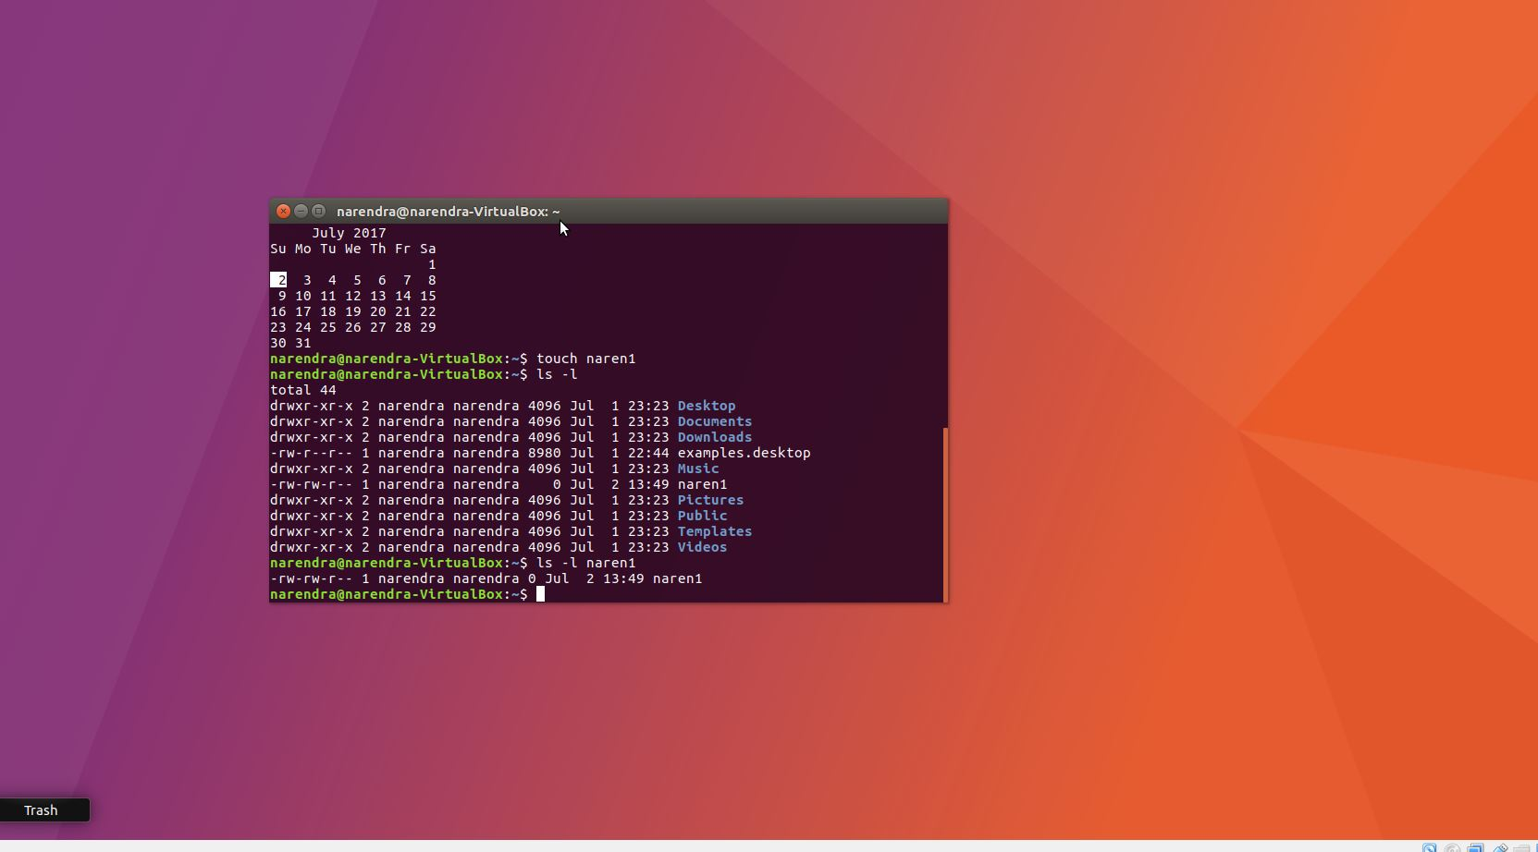
file creation using touch

touch naren1

ls -l naren1

displays file permissions

change file permissions by adding 777

